© Newmar Power Supplies. The information contained herein is subject to change without notice. Newmar shall not be liable for technical or editorial errors or omissions contained herein. All rights reserved.
Owners Manual
DP10‐LED‐12
Power Distribution Panel

Table Of Contents
Table of Contents
Table Of Contents 1
Description 2
Specifications 2
INSTALLATION WARNING 2
CONDUCTOR PRETREATMENT 3
RECOMMENDED COPPER WIRE SIZE FOR CURRENT CAPACITY 3
LIMITED WARRANTY 4
Contact Us 5

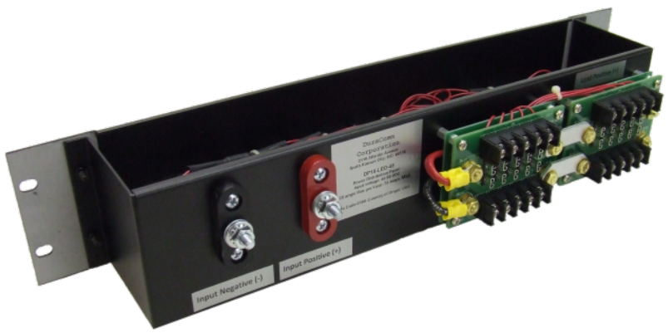
- Front panel LEDs indicate circuit condition (open/closed)
- Access power from 10 outputs, 20 amps maximum per output
- 75 amps maximum
- Uses standard ATC/ATO blade fuses (no included) for use with 12 volt systems
- 3 year warranty

Description
This DP10-LED-12 power distribution panel is designed for use with 12 volt system. It offers up to 75 amps, and can access power from 10 outputs, 20 amps maximum per output.

Specifications
Operational DC Voltage 12.0 VDC, nominal
Maximum Current, continuous 75 Amps
Input Voltage Range 5-15 VDC
Working Temperature range -4 - 140 F (-20- +60 C)
Storage Temperature -40 - 185 F (-40 - +85 C)
Size 3.5H x 19W x 4.5D inches, nominal
Weight 5.0 lb, nominal

INSTALLATION WARNING
The individual user should take care to determine, prior to use or installation, whether this device is suitable, adequate or safe for the use intended. Since individual applications are subject to great variation, DuraComm makers no representation or warranty as to the merchantability, suitability or fitness of these units for any specific application.

Failures require investigation as to cause and/or repair of the unit.

THERE ARE NO USER SERVICEABLE PARTS INSIDE. HAZARDOUS VOLTAGES EXIST INSIDE THE UNIT. SERVICE AND REPAIR MUST BE REFERRED TO QUALIFIED FACTORY PERSONNEL.

CONDUCTOR PRETREATMENT
All kinds of copper conductors can be clamped without treatment. DO NOT solder tin stranded conductors. The solder yields and fractures under high pressure. The result is increased contact resistance and excessive temperature rise. Additionally, corrosion has been observed due to the fluxes. Notch fractures at the transition from the rigid tinned part to the flexible conductors are also possible. Ferrules can be used as a protection when wiring stranded conductors. Copper ferrules prevent the current transfer from being influenced by dissimilar metals and remove the risk of corrosion. Always use the correct tool to crimp the ferrule.

RECOMMENDED COPPER WIRE SIZE FOR CURRENT CAPACITY
(Insulated Wire, Single Conductor in free air)

Current Level in Amperes | Wire Size
<7 AMPERES | 20 AWG Up to 5 feet  18 AWG Up to 10 feet
14 AMPERES | 18 AWG Up to 5 feet  16 AWG Up to 10 feet
20 AMPERES | 16 AWG Up to 5 feet  14 AWG Up to 10 feet
30 AMPERES | 14 AWG Up to 5 feet  12 AWG Up to 10 feet
40 AMPERES | 12 AWG Up to 5 feet  10 AWG Up to 10 feet
50 AMPERES | 10 AWG Up to 5 feet  8 AWG Up to 10 feet
70 AMPERES | 8 AWG Up to 5 feet  6 AWG Up to 10 feet
100 AMPERES | 6 AWG Up to 5 feet  4 AWG Up to 10 feet

LIMITED WARRANTY
DuraComm warrants to the initial end user, each power supply manufactured by DuraComm to be free from defects in material and workmanship, when in normal use and service for a period of three years from the date of purchase, from an authorized DuraComm dealer.

Should a product manufactured by DuraComm fail or malfunction due to manufacturing defect, or faulty component, DuraComm, at its option, will repair or replace the faulty product or parts thereof, which, after examination by DuraComm, prove to be defective or not operational according to specifications in effect at the time of sale to the initial end user. The product that is replaced or repaired under the provisions of this warranty, will be warranted for the remainder of the original warranty period, only, and will not extend into a new three-year warranty period.

The limited warranty does not extend to any DuraComm product which has been subject to misuse, accidental damage, neglect, incorrect wiring not associated with manufacture, improper charging voltages, or any product which has had the serial number removed, altered, defaced, or changed in any way.

DuraComm reserves the right to change, alter, or improve the specifications of its products at any time, and by so doing, incurs no obligation to install or retrofit any such changes or improvements in or on products manufactured prior to inclusion of such changes.

DuraComm requires any product needing in or out of warranty service to be returned to DuraComm. All requests for warranty service must be accompanied by proof of purchase, such as bill of sale with purchase date identified. DuraComm is not responsible for any expenses or payments incurred for the removal of the product from its place of use, transportation, or shipping expenses to the place of repair, or return expenses of a repaired or replacement product to its place of use.

The implied warranties which the law imposes on the sale of this product are expressly LIMITED, in duration, to the three (3) year time period specified herein. DuraComm will not be liable for damages, consequential or otherwise, resulting from the use and operation of this product, or from the breach of this LIMITED WARRANTY.

Some states do not allow limitations on the duration of the implied warranty or exclusions or limitations of incidental or consequential damages, so said limitations or exclusions may not apply to you. This warranty gives you specific legal rights which vary from state to state.

This warranty is given in lieu of all other warranties, whether expressed, implied, or by law. All other warranties, including WITHOUT LIMITATION, warranties of merchantability and fitness or suitability for a particular purpose, are specifically excluded. DuraComm reserves the right to change or modify its warranty and service programs without prior notice.

Contact Us

Location  6655 Troost Avenue  Kansas City, MO. 64131 | Phone  816.472.5544  1.800.467.6741 | Fax  816.472.0959 | Email  Email purchase orders to order@duracomm.com

