



© Newmar Power Supplies. The information contained herein is subject to change without notice. Newmar shall not be liable for technical or editorial errors or omissions contained herein. All rights reserved.

**Owners Manual**

*​​* *DC-RMCU-8G SITEGRAPH*

*DIN Mount DC-Powered Remote Monitoring and Control Unit*

# Table Of Contents

Table of Contents

Table Of Contents 1

Description 2

Important Safety Instructions 3

Product Overview 4

Installation 4

Operation 4

Specifications 5

WARRANTY 8

Contact Us 9

# Product

* DC-Powered Remote Monitoring and Control Unit for Remote Site Management and Industrial Internet of Things (IIoT) Applications.
* Graphing for Each Analog Input.
* DIN or Wall Mounting.
* Accessory Kit Supplied
* 3 Year Warranty

# Hardware

* Universal DC power input: 9 ~60 VDC.
* 8 Analog inputs using 24 bit ADCs:
  + 4 AC or DC voltage sensors (jumper selectable) (Ch1 to Ch4)
  + 4 DC only voltage sensors (Ch5 to Ch8)
  + DC range -100 to +100 VDC or -2 to +2 VDC (jumper selectable), 2% accuracy
  + AC range 30 to 300 VRMS AC, 2% accuracy
  + Standard Configuration: CH 1 & Ch2 configured for AC. CH3 configured for Amperage with included external shunt for +100 to -100 amps at 2% accuracy. Ch4 thru Ch8 configured for +/- 100VDC.
  + Up to 7 additional DC current sensors can be added. Each sensor uses 1 of the DC or AC voltage inputs. Additional sensors must be purchased separately and installed /calibrated at the factory.
* 1 internal temperature and humidity sensor
* 1 external temperature probe (TC74)
* User selectable Fahrenheit or Celsius scales
* Additional temperature sensors can be added. These are LM35 Sensors. Additional sensors must be purchased separately and installed/calibrated at the factory. Each sensor uses one of the 8 analog channels.
* 10 fully opto-isolated digital inputs for door alarms, status inputs, and DC-OK signals
* 8 fully opto-isolated digital outputs for logic, alarms, relays, and switches, with Single Pulse and PWM capability.
* 4 Digital to Analog outputs with 0 to 10 Volt Output.
* TCP/IP communication through a standard RJ-45, 10/100 Ethernet

# Firmware (Version 3.14)

* Web Ready / Web GUI / Mobile Status Page
* Graphing of data for each analog input.
* Bar Graphs with Alarm settings and Alarm Status Color.
* HTTPS self-generated web page. Plug-and-Play. No downloads or additional software required.
* User customizable inputs and outputs.
* Email alerts and scheduled status emails.
* User configurable alarm thresholds and delays with auto or manual recovery.
* Remote power cycling (on/off or momentary) of circuit breakers, repeaters, routers, power supplies, etc through Digital Outputs.
* SNMP v1, v2, & v3 integration with MIB from DuraComm.com
* SMTP/POP3 – email alerts
* 2 User Levels with different permissions
* Admin Can Configure up to 8 Users with 2 Different Permission Levels.
* Manual or NTP Time Setting
* Log and Download Time stamped Readings and Alarms, stored on internal SD card and downloadable .CSV file.
* Custom User Units and calibration for Linear Transducers
* Control Digital Outputs based on Analog Input Alarm.
* Schedule Digital (GPIO Mode) or Analog Output Changes at Specific Times.
* SNMP Version 1, 2 and 3 compatible.
* Configurable Labels and Buttons for Each Digital Output.
* Optional Analog Input Averaging.
* Configure Analog and Digital Alarm Delay Duration (Holdoff) before triggering to Avoid Transient Alarms.
* Remote reboot.
* User controlled remote software update over TCP/IP
* Easy to use screw terminal blocks.

# SITEGRAPH Description

The new SITEGRAPH DC-Powered Remote Monitoring and Control Unit (RMCU) is a flexible product for remote site monitoring and control, and Industrial Internet of Things (IIoT) applications. The SITEGRAPH provides 8 high-resolution analog inputs, 10 digital inputs, 8 digital outputs, and 4 analog outputs that are highly configurable. All of these channels are visible on the home page with alarm status, and all analog channels are displayed as bar graphs with alarm setting indicators, and alarm status color.

Four of the analog inputs can be configured as AC or DC inputs via jumper, the other four are DC only. AC Voltage measurement is configured via jumper and calibrated at the factory for 30 to 300 V RMS, and DC measurement can be configured via jumper, with a separate jumper for +/- 100 VDC or +/- 2 VDC range. Measurement function (AC or DC) must be set and calibrated at the factory. DC values can be fine-tuned or converted and calibrated to user units in the field or at the factory.

Digital outputs can be configured for simple ON/OFF, Pulse, or PWM operation. Digital Inputs can be configured to show OPEN or CLOSED contacts, Pulse Count, or Frequency count within ranges.

The standard configuration from DuraComm is as follows:

* Analog Channels 1&2: AC Voltage Measurement
* Analog Channel 3: Amperage (+/- 100 Amps)
* Analog Channels 4 thru 8: +/- 100 VDC
* Digital Inputs: 1 thru 10, Open/Closed
* Digital Outputs: 1 thru 8: GPIO (Open/Closed)
* DAC Outputs: 0 VDC

Changes to digital outputs or analog outputs can be scheduled to happen at specific times and days of the week.

Alarms and email notifications can be configured for the analog and digital inputs. Temperature alarms can be set for the external temperature. The SITEGRAPH also sends SNMP Traps for alarm conditions. The SITEGRAPH can also be set to log measurements to an internal micro SD card, and the measurements are time-stamped with a real-time clock.

Guest users will see the status page that displays the measured values and alarm condition of all active channels, temperature value and alarm condition, as well as alarm input status, and control status. The default status page shows bar graphs of the analog channels, with alarm status color, and alarm limit settings, if they are within the bar chart limits. Click the “See charts” button to display the line charts for the analog channels. Each graph displays 1440 points of data, sampled at a configurable rate from 1 min (1 day chart) to 28 minutes (4 week chart). You can also switch to the live view that charts data taken approximately every 0.5 second. Live View is for display only. Archive charts can be downloaded as a CSV file by clicking the icon for each channel.

A mobile friendly version of the status page is also included that shows measured values and alarm condition.

**NOTE: If the SITEGRAPH board is installed in a product such as a power supply or other focused product, some channels or features may not apply. Unused channels and features are hidden or grayed out to simplify the user interface for that product.**

Admin and Control Users will be able to configure all of the input and output settings, and set the state of the digital outputs. Admin and Control users can set device settings for logging, time, and Site Name. Admin users have exclusive control of network configuration, including manual time setting or NTP, soft reboot of the SITEGRAPH, factory reset of the entire configuration, and user passwords.

The SITEGRAPH comes with the DuraComm three-year warranty.

# Specifications

|  |  |
| --- | --- |
| Hardware Revision | 3.0 |
| Firmware Revision | 3.15 |
| DC Input Power | 9 to 60 VDC @ 500 mA max |
| Internal +5VDC supply current (Source for external Logic) | 300 mA Max |
| Analog (Voltage) Isolated Input Channels (8 channels – Factory Configured and Calibrated) | |
| AC Measurement (AC Jumper in place, and 2 V jumper in place) | 30 to 300 VAC RMS, +/- 2% |
| DC Measurement 100 V Range (DC Jumper in Place – Without 2 V Jumper) | +/- 100 VDC, +/- 2% |
| DC Measurement 2 V Range (DC Jumper in Place – With 2 V Jumper in place) | +/- 2 VDC, +/- 2% |
| Digital to Analog Outputs (4 Channels) | 0 to 10 V, 20 mA max |
| Digital Alarm Input Channels (10 channels – fully Isolated) | LED with 220 Ohm Series Resistor, 50 mA Max (per channel) |
| GPIO CLOSED | 5 VDC from Input + to Input –, Use External Resistor in series to Increase Voltage Tolerance for 15 mA |
| GPIO OPEN | 0 VDC from Input + to Input – |
| Pulse Count | Use GPIO Levels above for p-p input |
| Freq | Use GPIO Levels above for p-p input, Ranges 4 Hz to 2.4 KHz, 15 Hz to 9 KHz, 120 Hz to 75 KHz, 1 KHz to 600 KHz, Accuracy, 1Hz |
| Digital Output Channels (8 Channels– Fully Isolated) | |
| GPIO (Active, Inactive or Single Pulse Modes) | Open Drain FET, 60 VDC Max, 500 mA sink Max (per channel) |
| PWM (All Channels – Full Isolation Jumper in place for CH 7 thru Ch 10) | 125 Hz Max (Duty Cycle = Active/Period) |
| PWM (Ch 7 thru Ch 10 – Isolation Bypass Jumper in place) | TTL Logic, reference = G, Select 750 Hz, 7.5 KHz, 75 KHz |
| Network Connector | RJ-45 (10/100 Ethernet) with activity LEDs |
| Backup Battery (for Real Time Clock) | CR2032 |
| Memory Card | Micro SD |
| Alarm Notifications | Email and/or SNMP |
| Logging Rate | 1 minute resolution, 1 minute to 1 hour |
| Log Download Format | Comma Separated Values (CSV) File |
| Line Chart Archive Sample Rate (Minutes) = chart width (1440 samples). Download is .CSV file for each Channel. | 1 Min=1 Day, 2 Min=2 Days, 7 Min=1 Week, 14 Min=2 Weeks, 28 Min=4 Weeks |
| Line Chart Live Sample Rate (Approximate) | 0.5 seconds/sample |
| Temperature Measurement (Internal) | -40 C to 125 C, +/- 1 C |
| Humidity (Internal) | 0 to 100 %, +/- 5% |
| Temperature Measurement (External) | +77 F to +185 F (+25 C to +85 C), +/- 2% |
|  | +32 F to +257 F (+0 C to +125 C), +/- 2% |
| Working Temperature Range | -22 F to +140 F (-30 C to +60 C) |
| Storage Temperature | -40 F to +185 F (-40 C to +85 C) |
| Dimensions | 10” H x 3.5” W x 5.5” D |
| Weight | 2 lbs |

# Accessory Kits (Included)

|  |  |
| --- | --- |
| Ethernet Cable | 3 feet |
| Current Measurement Shunt | 100 Amp / 50 mV |
| Temperature Sensor | TC74A5-3.3VAT with 18” Shielded Cable (Shield attached to tab of sensor and G) |
| Rubber Feet | 4 |
| Wall-Mount Brackets | 2 |

# Installation

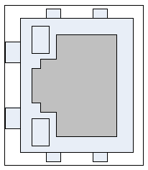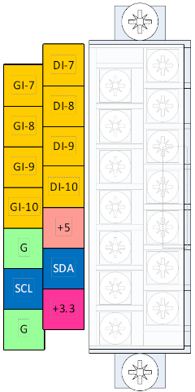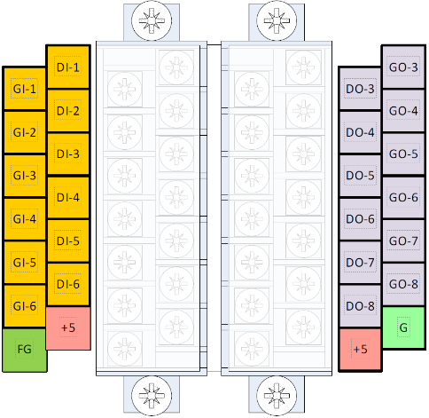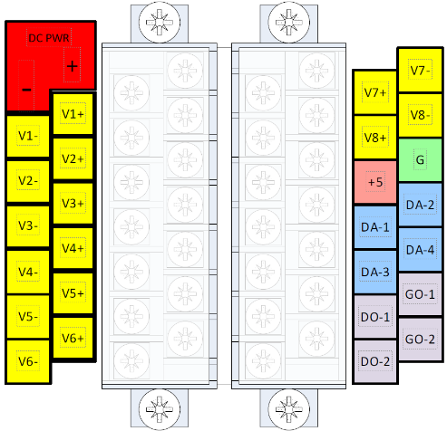

## Generic

DC Power to SITEGRAPH, 0-60VDC

Analog (ADC) Inputs V1 thru V8

Analog (DAC) Outputs (0-10 VDC) DA-1 thru DA-4

+5 VDC Power From SITEGRAPH

Digital Outputs DO-1 thru DO-8

Digital Inputs DI-1 thru DI-10

Ground for +5 and +3.3 VDC Power From SITEGRAPH I2C Clock and Data for TC74 External Temperature

+3.3 VDC for TC74 External Temperature

Frame Ground

# Generic

## Standard Configuration V1, V2, V3

L1, N1 = AC Monitor 1

L2, N2 = AC Monitor 2

V3+, V3- = Current Shunt (+/- 2 VDC MAX)

# Input Power

Connect the SITEGRAPH DC PWR connections on the power strip. Please be sure to connect the positive terminal to the positive (+) supply lead, and the negative terminal to the negative(-) supply lead. The supply voltage may be 9 VDC to 60 VDC. Connect Frame Ground to your Earth ground.

# 10/100 Ethernet

Connect the RJ-45 on the SITEGRAPH to your network with an Ethernet patch cable. A short 3 foot cable is provided with the SITEGRAPH.

**NOTE: The USB connector on the board is for factory diagnostics only.**

WARRANTY

DuraComm warrants to the initial end user, each power supply manufactured by DuraComm to be free from defects in material and workmanship, when in normal use and service for a period of three years from the date of purchase, from an authorized DuraComm dealer.

Should a product manufactured by DuraComm fail or malfunction due to manufacturing defect, or faulty component, DuraComm, at its option, will repair or replace the faulty product or parts thereof, which, after examination by DuraComm, prove to be defective or not operational according to specifications in effect at the time of sale to the initial end user. The product that is replaced or repaired under the provisions of this warranty, will be warranted for the remainder of the original warranty period, only, and will not extend into a new three-year warranty period.

The limited warranty does not extend to any DuraComm product which has been subject to misuse, accidental damage, neglect, incorrect wiring not associated with manufacture, improper charging voltages, or any product which has had the serial number removed, altered, defaced, or changed in any way.

DuraComm reserves the right to change, alter, or improve the specifications of its products at any time, and by so doing, incurs no obligation to install or retrofit any such changes or improvements in or on products manufactured prior to inclusion of such changes.

DuraComm requires any product needing in or out of warranty service to be returned to DuraComm. All requests for warranty service must be accompanied by proof of purchase, such as bill of sale with purchase date identified. DuraComm is not responsible for any expenses or payments incurred for the removal of the product from its place of use, transportation, or shipping expenses to the place of repair, or return expenses of a repaired or replacement product to its place of use.

The implied warranties which the law imposes on the sale of this product are expressly LIMITED, in duration, to the three (3) year time period specified herein. DuraComm will not be liable for damages, consequential or otherwise, resulting from the use and operation of this product, or from the breach of this LIMITED WARRANTY.

Some states do not allow limitations on the duration of the implied warranty or exclusions or limitations of incidental or consequential damages, so said limitations or exclusions may not apply to you. This warranty gives you specific legal rights which vary from state to state.

This warranty is given in lieu of all other warranties, whether expressed, implied, or by law. All other warranties, including WITHOUT LIMITATION, warranties of merchantability and fitness or suitability for a particular purpose, are specifically excluded. DuraComm reserves the right to change or modify its warranty and service programs without prior notice.

# Contact Us

|  |  |  |  |
| --- | --- | --- | --- |
| Location  6655 Troost Avenue  Kansas City, MO. 64131 | Phone  816.472.5544  1.800.467.6741 | Fax  816.472.0959 | Email  ­  Email purchase orders to order@duracomm.com |
|  |  |  |  |

